# Create and populate Dimension of TIME DW – Layer

## Task 01: CREATE DW.T_DAYS

## Task 02: CREATE DW.T_WEEKS

## Task 03: CREATE DW.T_MONTHS

## Task 04: CREATE DW.T_QUARTERS

## Task 05: CREATE DW.T_YEARS

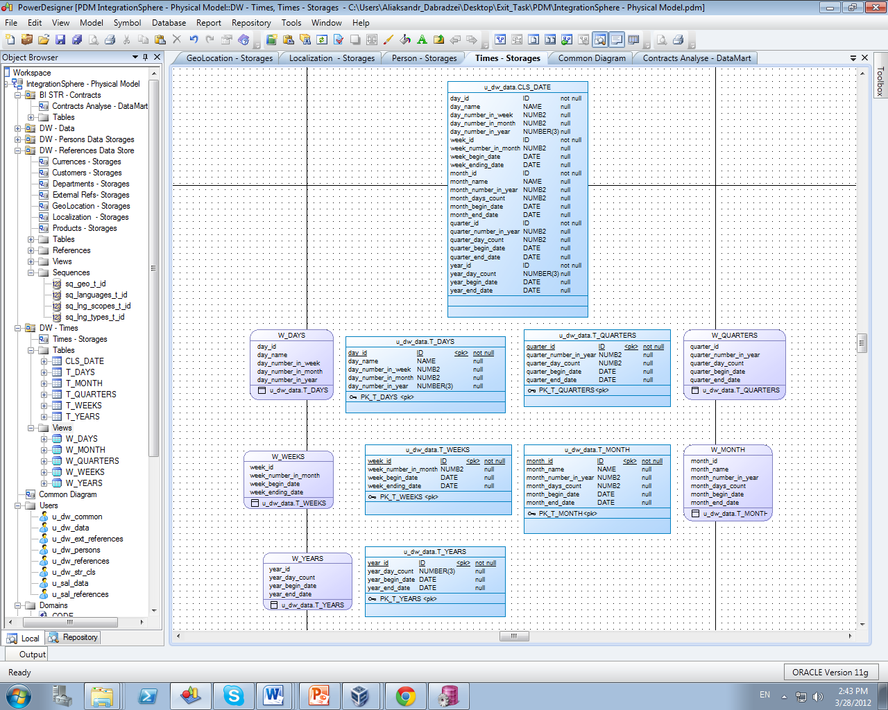

<https://github.com/MinskLab2012-March/Module6_Labs/blob/master/Exit_Task/Aliaksandr_Dabradzei/lab_scripts/u_dw_data/Packages/pkg_load_times-def.sql>

<https://github.com/MinskLab2012-March/Module6_Labs/blob/master/Exit_Task/Aliaksandr_Dabradzei/lab_scripts/u_dw_data/Packages/pkg_load_times-impl.sql>

# OLAP – Business analyses task

## Task 06 – Solution concept – Add: Chapter Dimensions Types

**The Main Task** is to create summary table to describe all future STAR Dimensions:

Next points are mandatory:

* Start scheme must use no less one of SCD type 2 Dimension
* Start scheme must use prepared dimensions: DIM_TIME, DIM_GEO_LOCATIONS
* Start scheme must use one of period dimensions: DIM_GEN_PERIODS

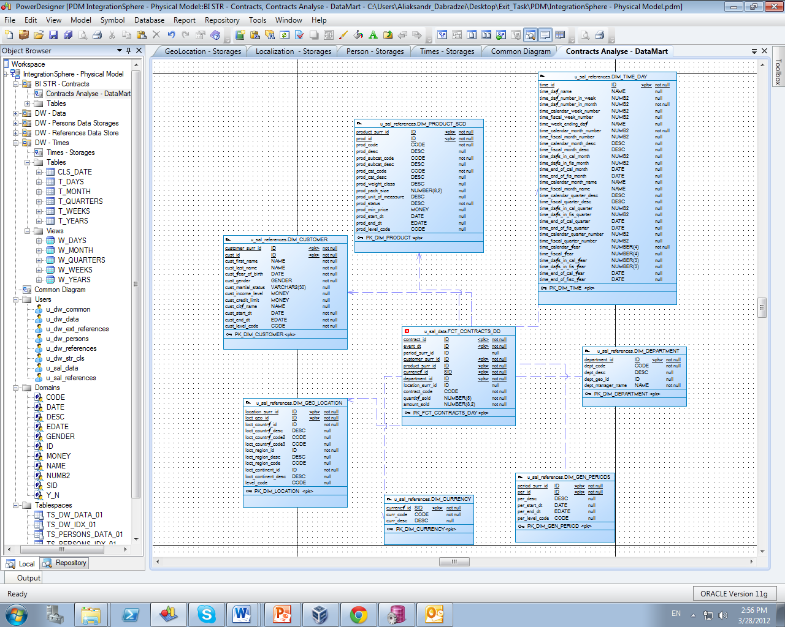

**Task Results:**

Create document, which contained next chapters:

* + Chapter: Dimensions Types Description

|  |  |  |  |  |
| --- | --- | --- | --- | --- |
| Name | Type | Size | DW – Merged Dimensions | Descriptions |
| DIM_ TIME_DAY | SCD1 | BIG | DW.T_DAYS, DW.T_WEEKS, DW.T_MONTHS, DW.T_QUARTERS,  DW.T_YEARS | It is a specific type of dimension. Appears at the DWR and contains all the time since the introduction of the project until its completion. |
| DIM_CURRENCY | SCD1 | SMALL | DW.T_CURRENCY |  |
| DIM_CUSTOMER_SCD | SCD2 | BIG | DW.T_CUSTOMERS,  DW.T_CUST_ADDRESSES,  DW.T_CUST_TECHN_INF |  |
| DIM_DEPARTMENT | SCD1 | SMALL | DW.T_DEPARTMENTS |  |
| DIM_GEN_PERIODS | SCD1 | SMALL | DW.T_PERIODS |  |
| DIM_GEO_LOCATIONS | SCD1 | BIG | DW.T_COUNTRIES  DW.T_CNTR_GROUPS  DW.T_CNTR_SUB_GROUPS  DW.T_GEO_TYPES  DW.T_GEO_SYSTEMS  DW.T_GEO_PARTS  DW.T_GEO_REGIONS  DW.T_GEO_OBJECTS  DW.T_CNTR_GROUP_SYSTEMS |  |
| DIM_PRODUCT_SCD | SCD2 | BIG | DW.PRODUCTS,  DW.PRODUCT_SUBCAT  DW.PRODUCT_CAT  DW.PRODUCT_SALES |  |

## Task 07 – Solution concept – Add: Chapter Dimensions Hierarchies

**The Main Task** is to create summary table to describe all future STAR Dimensions Hierarchies:

Next points are mandatory:

* Start scheme must use no less one of SCD type 2 Dimension
* Start scheme must use prepared dimensions: DIM_TIME, DIM_GEO_LOCATIONS
* Start scheme must use one of period dimensions: DIM_GEN_PERIODS

**Task Results:**

Create document, which contained next chapters:

* + Chapter: Dimensions Hierarchies

**DIM_GEN_TIME:**

**Hierarchy DAY-WEEK-MONTH-QUARTER-YEAR**

|  |  |  |  |
| --- | --- | --- | --- |
| Name | LEVEL_CODE | LEVEL_DESC | LEVEL_NATURAL_KEY |
| DAYs | DAY | Store all day at the calendar | DAY_ID |
| WEEKs | WEEK | Store all weeks at the calendar year | WEEK_ID |
| MONTH | MONTH | Store all month at the calendar year | MONTH _ID |
| QUARTERs | QUARTER | Store all quarters at the calendar year | QUARTER _ID |
| YEARs | YEAR | Store all years | YEAR_ID |

**DIM_PRODUCTS_SCD:**

**Hierarchy PRODUCTS –-SUBCATEGORY-- CATEGORY**

|  |  |  |  |
| --- | --- | --- | --- |
| Name | LEVEL_CODE | LEVEL_DESC | LEVEL_NATURAL_KEY |
| PRODUCTS | PROD_NAME | Store all possible products for each category. | PROD_ID |
| SUBCATEGORIES | PROD_SUBCATEGORY | Store all product subcategories for each category. | PROD_SUBCATEGORY_ID |
| CATEGORIES | PROD_CATEGORY | Store all product categories of our company. | PROD_CATEGORY_ID |
|  |  |  |  |

**DIM_GEO LOCATIONS:**

**Hierarchy COUNTRY –-SUBREGION--REGION**

|  |  |  |  |
| --- | --- | --- | --- |
| Name | LEVEL_CODE | LEVEL_DESC | LEVEL_NATURAL_KEY |
| COUNTRIES | COUNTRY_NAME | Store all countries for each region. | COUNTRY_ID |
| REGIONs | COUNTRY_REGION | Store all regions of the world. | COUNTRY_REGION_ID |
| CONTINENTs | COUNTRY_CONTINENT | Store all continents of the world. | COUNTRY_ CONTINENT _ID |

## Task 08 – Solution concept – Add: Chapter Facts Aggregations

|  |  |  |  |  |
| --- | --- | --- | --- | --- |
| Name | Code | Table Name | Additive | Descriptions |
| Counts amount sold products by day | AMOUNT_SOLD | FCT_CONTRACTS_DD | + | Calculate distinct values of Contracts at the event_dt period. |
| Counts quantity sold products by day | QUANTITY_SOLD | FCT_ CONTRACTS_DD | + | Calculate distinct values of Contracts Products at the event_dt period. |